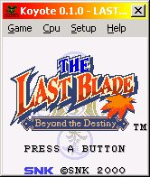
Koyote is a Freeware Neo Geo Pocket emulator written by David Raingeard and Romain Tisserand.

